Day 1
- Core concepts of AI, ML, Deep learning, Gen AI
- Understanding LLM behaviour
- Why LLM testing is different (Optional) - Not for the traditional QA team
- Application of Gen AI in testing
- Prompt engineering
- Sampling parameters (temperature, top p, top k)
- Some hands-on for manual testing.

Day 2
- Github Copilot Features - plan, agent, ask → VERY IMPORTANT FOR QA Team/Non technical team (3 hours)
- MCP - VERY IMPORTANT FOR QA Team/Non-technical team

Below for technical people:

- Creating some agents → using the LLM model at the code level (NOT MANDATORY - BUT GOOD TO KNOW IF YOU WANT LLM OUTPUT AT CODE LEVEL) - (2 hours)

- How to test the LLM model using deep eval (only if your project development agent - using the LLM model for building it)

GEN AI - Final Goal to work ON

- Core Concepts
  - AI - AI is a broader concept of machines performing tasks
    - Typical required human intelligence
Example: self-driving car

  - Machine Learning is a subset of AI where a system learns patterns from data instead of being explicitly programmed

Instead of writing rules
income >50, 0000 and credit score >700

ML learns patterns automatically from historical data.

Classified into two types mainly
- Supervised learning
  - Target column (price or yes/no)
  - Some Supervised models are Linear Regression, Logistic Regression:
- Unsupervised learning
  - Won’t target column
  - Some unsupervised models - K-means Clustering, Hierarchical Clustering
  - Example: Customer segmentation
    - High spender
    - Medium spender
    - Low spender

  - Deep Learning - a subset of ML that uses neural networks with multiple layers (deep neural networks). DL is the underlying method used to build the model.

Best for: text generation, image recognition, speech
Example:
Language models like gpt-4, gpt-5 in chatgpt

Types of deep learning
- Transformer model/architecture (LLM) → LLMs are primarily trained on text data, but modern LLMs can also handle images, audio, and other modalities
- CNN - image classification
- Diffusion model - image generation (possibly get used along with transfer model)

  - Gen AI (capability of AI systems) that creates new content - text, images, code, audio,
    - Gen AI describes what the model does, not how it is built.
    - It is powered by deep learning models such as:
      - Transformer model (for text generation)
      - Diffusion model (for image generation)

Example: Applications like ChatGPT or Claude provide user access to these generative AI systems
- Text generation - chatgpt
- Code generation - GitHub Copilot

Difference between AI/ML/DL/Gen AI

AI | ML | DL | Gen AI
Broad | Subset of AI | Subset of ML | Subset of DL
Mimic intelligence | Learn from data | Learn complex pattern | Generate new content

Understanding LLMS behaviour
- What is an LLM (Large Language Model)
  - LLMs are specific DL models trained on text for understanding/generating language, but modern LLMs can also handle images, audio, and other modalities
Example:
GPT (Generative pre-trained transformer model)
Gemini
How LLMs work
LLMs learn by
- Reading huge amounts of text
- Learning patterns
- Predicting the next words in a sentence

Over time, this simple idea becomes powerful enough to
- Answer question
- Write essay
- Generate code
- Hold conversions

AI->ML->DL-> LLMs → GPT model (gpt 4, 5) → ChatGPT (application using GPT) or api interfaces or libraries, specific programming language.

Gen AI is not rule-based like automation scripts.
It’s probabilistic (non-deterministic)

- Why LLM testing is different (Optional) - Not for the traditional QA team -but the AI-QA team that tests the LLM model
  - Deepeval framework available to test the build LLM
  - BLEU score check

- We are going to use LLM for manual testing and automation testing of traditional qa work - the QA team will use the LLM model for performing traditional qa testing.

- Understand behaviour LLM
  - Non-deterministic
  - Token, context window, sampling parameters

Traditional software
Same input → same output (deterministic)
LLMs:
Same input → different output possible (non - deterministic)

This happens because
- Probability -based word selection
- Temperature, top p, top k (randomness control) - sampling parameter

- Token -
Tokenization example:
The capital of France is Paris.

6 words, token as 7, 31 character

[The, capital, of, france, is, paris, .] = 7 token

Approx → 4.4 characters per token (characters/token)

- Context window - maximum number of tokens the model can remember.
  - It includes
    - Current question
    - Previous conversion
    - System instruction
    - Model responses (assistant replies)

Whiteboard → context window
Words written on it → token
When the board is full → old stuff gets erased.

- Application of GenAI in testing
  - Test case generation
  - Test data generation
  - Bug identification
  - Documentation → test strategy, plan
  - Code generation

- Prompt Engineering
  - What makes it a good prompt?
    - A good prompt is → clear, specific, context aware, structured
    - Key formula → ROICEF (Role+objective+input+contraints+expected format+few shot)
Role → who the model should act as
Objective → what needs to be done
Input → background info/data/
Constraints → limits or rules
expected format → structure
Optional
Few-shot examples

Example:
Role: You are a QA automation engineer
Objective: generate test cases for login functionality
Input: Login features include email and password authentication
Constraints:
- Positive and negative scenarios
- Maximum 6 testcases
- Keep steps concise
expected format:
Table with columns
| testcaseid | steps | expected results|
    - RACE, IDEA, Chain of thoughts (alternate to ROICEF)
    - RACE - Role+action+context+expectation
      - Role: You are qa tester
      - Action: generate test case
      - Context: Fund transfer validation for the amount and account number
      - Expectation- include positive, negative, and edge cases in table format
    - Chain of thoughts: -> AI thinks step by step
      - Example: Generate a test case step by step
        - Identify validation
        - Create positive scenarios
        - Add a negative scenario
        - Add edge case

  - Zero shot vs few shot prompting
    - Zero shot
      - No example → classify sentiment: I love the product
    - Few shot
      - Provide
Example
Text: I love the product
Sentiment: positive

Text: I hate the product
Sentiment: negative

Text: I love the product, but hate the product
Sentiment: mixed

  - System vs user prompt
    - System prompt defines
      - The model’s role
      - The tone
      - The rules
      - Act like Policy layer
    - User prompt
      - The actual question
      - Task request
      - Input from the user

  - Prompt template & best practice
    - Use demilters (“”” or ``` )
Weak prompt: summarize the following text: the cat sat on the mat
Better prompt:
Summarize the text:
“””
The cat sat on the mat.
“””
    - Specific format
    - Limit length

- Sampling parameter
  - Temperature (control randomness)
    - Low (0 - 0.3) - predictable and stable
    - High (0.7 to 1) → creative, varied

Example:
Prompt → The capital of France is Paris

Temperature 0 → Yes, that's correct.
Temperature 1 → That is correct. Paris is a world-renowned city, famous for its art, fashion, culture, and historical landmarks.

Range:
0 → more deterministic
0.1 - 0.3 → very stable
0.7 → default creative
>1 -> very random
>2 → often unstable

  - Top P (0<top<=1)
    - What it controls - probability mass selection
    - It selects from the top probability token until the cumulative probability = p

Prompt
Example: I am feeling ____

It assigns probabilities
- happy (0.30)
- Good (0.25)
- tired (0.25)
- sad (0.10)
- excited (0.10)
Case 1:
If Top p = 0.9 →
- happy (0.30)
- Good (0.25) → 0.3+0.25 0.55
- tired (0.25) → 0.55+0.25 = 0.80
- sad (0.10) → 0.80+0.1 → 90% → stop here
- excited (0.10)

So no 4 tokens are considered

Range:
1→ all tokens allowed
0.9 → only top 90% cumulative probability
0.5 → very restricted
<0.3 → more deterministic

  - Top k (1<top_k<vocoblary size)
    - Smaller K → more deterministic
    - Larger k → more diverse

Prompt:

Example: I am feeling ____

It assigns probabilities
- happy (0.30)
- Good (0.25)
- tired (0.25)
- sad (0.10)
- excited (0.10)

Top k → 3 → only top 3 words are allowed.

  - Max token
- Control - maximum response length
- Prevent long answers
- Important for cost control
  - Frequency penalty (0 to 2)
- Reduce repetition of words
- 0 is no penalty - have more repeated words
- Increase - if you don’t need repetition

- Fund transfer feature of the banking system

- Requirement:
Feature: fund transfer
  - User enters:
    - From account
    - To account
    - Amount
    - Currency
  - Rules
    - Amount > 0
    - Valid account number
    - Sufficient balance

- Step 1: Generate test case

Role: You are an experienced QA engineer
Objective: Generate manual test cases for fund transfer
Input: User transfers money between accounts
Constraints: Include validation for invalid inputs and insufficient balance
Expected: Cover positive, negative, and boundary scenarios
Format: Provide testcases with TestCase ID, Steps, and Expected Result

→ ROICEF → how we controlled the output

- Step 2: Generate Test data (test type, account number, amount, currency, description)

Role: You are an experienced QA engineer
Objective: Generate test data for fund transfer functionality
Input: Fields include sender account, receiver account, amount, and currency.
Constraints: system should validate account numbers, amount >0, and support multiple currencies.
Expected: Include valid, invalid, and edge cases
Format: Provide output in table format with columns: Account number, amount, currency, description

- Step 3: BDD + Gherkins (ROICEF Style)
R: You are an experienced QA engineer
O: Convert fund transfer scenarios into Gherkin format
I: Fund transfer feature with validation
C: include both successful and failure scenarios
E: Include valid transfer, invalid, insufficient, and edge cases
F: Provide output in standard Gherkin syntax: Feature, Scenario, Given, When, Then

GitHub Copilot Features

- Github Copilot - It was a simple code completion tool (2022) to AI pair programmers that can handle code generation, multi-file edits, code review, and agent-based task completion
- Provide multi-model support
  - GPT
  - Claude
  - Gemini

Building a Python Selenium pytest framework from scratch

- Ask
  - What is it?
You ask a direct question to the copilot
  - When to use?
    - Explain the code
    - Generate a test for this function
    - Fix the error
    - Write a SQL query
- Agent (Autonomous mode)
  - Copilot becomes an AI agent (AI engineer inside your project) that can
    - Read your file
    - Navigate to the folders
    - Create/Update/Delete files
    - Refractor code

  - When to use it
    - Create a new Selenium page object for the login page
    - Add logging to all API methods
  - What happens internally?
    - Analyze project
    - Understand dependencies
    - Modify multiple files
    - Update imports
    - Execute changes

- Plan
- Creates a detailed action plan before making changes. (.md file)
- When to use
  - Big refactor
  - Multi-file changes
  - Setting up a framework

- Use plan →
Generate Prompt for plan
Prompt:
Create a scalable Selenium framework in Python using pytest
Requirement:
- Page object model
- Separate folders: tests, pages, utils, config, locators
- Webdriver driver integration
- Logging using the Python logging module
- Config management using YAML
- Generate HTML test report
Create a step-by-step plan.md including files to be created and changes to be made before implementation.

- Use Agent to build the framework using the plan
Prompt using the agent
  - Implement '1. Project Structure Setup'
  - Implement '2. Dependencies Installation'

- Use Agent to build the framework using the plan.md

- Custom instruction (similar to system instruction)
  - Configuration for Copilot to follow the coding standard and practice.

- Create test package and test module and test class
Add sample test method
Your are senior QA automation engineer

- Identify test_invalid_login
- Configure the browser and Facebook URL if required
- Complete invalid login test scenario
- Add a proper assertion

- Use Agent →
A class to work with a JSON file
Build a JSON file with invalid login data under the test_data folder

Use a chain of thoughts

Create a detailed step by step plan.md for working with windows automation.

- setup robotframework with flaui libraries and dependent libraries.
- Setup clean project structure to support all windows application automation
- Add configuration in YAML, such as app path
- Page object model needs to be configured
- Generate a Robot Framework report in the log folder

- Add a sample test case for the notepad launch check

- Copilot skills
Custom instruction → company rules
→ write clean code, follow standards

Skills = developer abilities
→ develop selenium scripts without page objects and assert them
→ then develop page object model

Now, if you do any prompt:
- Identify skills
- Apply instruction
- Avoid the agent and use ask
  - Small fixes
  - Single file changes
  - Simple queries
- Real workflow
  - Write instruction
  - Use plan mode
  - Review plan
  - Use agent mode
  - Validate output
  - Refine using ask

Plan → approve → execute → validate → improve

- Copilot limitation
  - May generate outdated code
  - May ignore edge cases
  - Limited understanding of business logic
  - Depends on the prompt quality

- MCP → Model Context Protocol - is a standard that allows LLM to connect with external tools, systems, and data

Architecture
User → LLM (GPT/Copilot) → MCP protocol → tools (playwright, DB, API) → real world actions

- To understand MCP (We can work on Typescript Playwright)

Create a TypeScript project and add Playwright MCP
  - Create project
  - Open terminal
  - npm init -y
  - npm install -D typescript
  - npm install -D ts-node
  - npm init playwright@lastest
  - Finally, install the MCP server:
  - npx playwright init-agents --loop=vscode

- Playwright MCP
  - Start server
  - Use playwright-test-planner →
Role: You are an automation engineer
Objective: Create a test plan for Facebook login functionality
Input: User email and password including valid, invalid and empty values
Condition: assume user account exists and application is accessible
Expectation:
- Successful login
- Invalid login with error message validation
Format: prepare detailed testplan.md file

- Selenium MCP
  - Add .vscode/mcp.json
"selenium": {
"command": "npx",
"args": ["-y", "@angiejones/mcp-selenium@latest"]
}

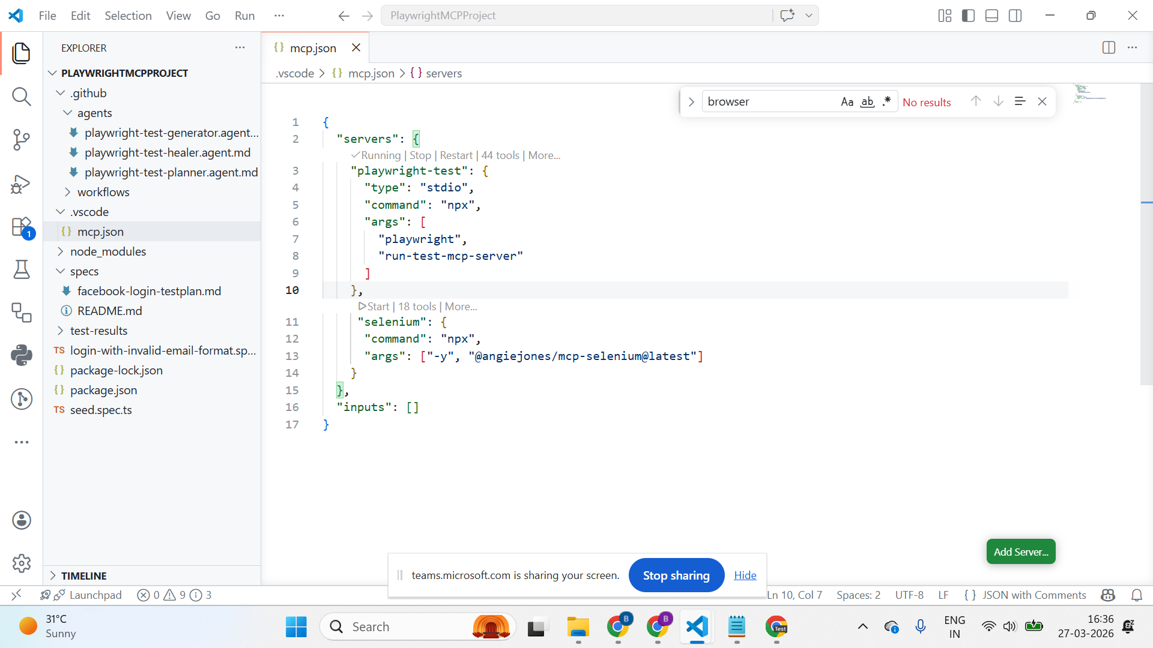

  - npm install -g @angiejones/mcp-selenium
  - Create a custom agent with that mcp server if not available
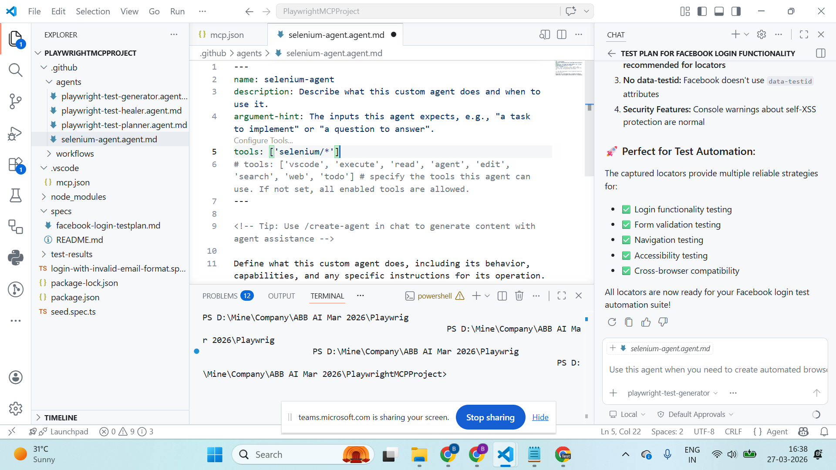

- How does MCP work?
  - User give instruction
  - LLM model understands intent
  - LLMs call tools via MCP
  - The tools will execute the action
  - Result sent back to LLM
  - LLM decides next step
  - This loop continues → agent behaviour

